Cooper Ritz, Tommy Devens, Grace Gavlinski
BIT 3484
5 May 2026
Final Capstone Project
Introduction

Kickstarter is a crowdfunding platform that reshaped how entrepreneurs bring ideas to market by enabling direct funding from the public. However, despite the accessibility of these platforms, only about 36% of projects reach their funding goals. While launching a campaign is easy, designing one that resonates with backers and secures funding is significantly more complex. For creators, failure can mean lost time, resources, and opportunity, and understanding success drivers is essential to improving campaign design, increasing funding efficiency, and ultimately maximizing the likelihood of project success.
From a business perspective, crowdfunding success represents a predictive problem with meaningful financial and strategic implications. If key factors that influence campaign outcomes can be identified, creators can optimize decisions such as funding goals, campaign duration, and project presentation. At the same time, platforms like Kickstarter can leverage these insights to improve user experience.
This project aims to apply classification models to predict whether a Kickstarter campaign will be successfully funded and to translate those predictions into actionable insights. The analysis is guided by the following research questions: what makes a Kickstarter campaign succeed or fail, is there an optimal funding goal, and what advice would you give a creator launching a new project to maximize their chance of funding?

Data

The dataset used in this analysis is a publicly available dataset of Kickstarter campaigns sourced from Kaggle. The working dataset contains 331,370 campaigns, filtered to include campaigns that had an outcome of "successful" or "failed," while campaigns that were live, canceled, or suspended were removed. This ensures that the analysis is based on completed campaigns with binary results. The dataset includes multiple key variables related to campaign performance, such as project category and main category, funding goal (in both local currency and USD), amount pledged, number of backers, campaign launch and deadline dates, and country of origin. The target variable for this analysis is a binary indicator of success (1 = successful, 0 = failed). Within the filtered dataset, the overall success rate is 40.4%, indicating a moderate class imbalance with failed campaigns occurring more frequently than successful ones.
To evaluate model performance, the data was split into training and test sets using a 70/30 split, resulting in 231,959 campaigns for training and 99,411 campaigns for testing. This approach allows us to train the model on a large portion of the data while still having a separate set to evaluate how well it performs on new data.

We also made several preprocessing decisions to clean and prepare the data. Missing values were minimal, so we removed them after feature engineering using Dropna() to keep as much data as possible. We also removed campaigns with errors, like campaigns with zero or negative durations. Categorical variables like main category and country were converted into numerical form using one-hot encoding so they could be used in the models. One of the biggest challenges in the dataset was the distribution of funding goals. The data is heavily right-skewed, with a few campaigns having extremely large goals that pull the average up. While the median goal is around $5,000, the mean is much higher at $41,150. To handle this, we created a log-transformed version of USD_goal_real, log_goal, which helps reduce the impact of outliers, allowing for more accurate analysis.

Looking at the data overall, most campaigns are relatively small, with lower funding goals and fewer backers, while a few outlier campaigns greatly inflate these averages. Campaign duration is also fairly consistent, with most campaigns averaging around 33 days, but the median and 25% percentile are both 29 days. Using these numbers, we can conclude that the majority of campaigns are open for 30 days.

Method

To prepare the data for modeling, we created a few new features from the original dataset. One of these features was campaign_days, which is the number of days between launch and deadline. We also created launch_month and launch_year to track when the campaign started. These variables help identify whether campaign timing affects the chance of success. Lastly, log_goal made the funding goal easier to work with, especially since it was heavily skewed. To avoid data leakage, variables like the number of backers, amount pledged, and total pledged in USD were not included in the models because they are only known after a campaign has already started or finished. Including them would have made the models unrealistically accurate without actually helping predict success ahead of time. We also simplified the category variable by using main_category instead of more detailed subcategories to keep the model easier to interpret.

To answer our research questions, we tested multiple classification models. We started with Logistic Regression as our baseline model. It is a linear model that estimates the probability of success based on a weighted combination of features. This makes it easy to interpret, since we clearly see how each variable increases or decreases the likelihood of success. The coefficients can be translated into odds ratios, which helps explain the impact of features like funding goal or campaign duration directly.

We then used a Random Forest model as a more flexible, non-linear alternative. Random forest builds many decision trees and averages their results, which helps reduce overfitting. Another advantage is that it provides feature importance, which helps us show which variables matter most in predicting the success of campaigns.

In addition to these two main models, we also tested Linear Discriminant Analysis (LDA) and a Decision Tree. Linear Discriminant Analysis (LDA) assumes the features are normally distributed within each class and finds the linear combination of features that best separates the two classes. We used a Decision Tree with a maximum depth of seven, which helps capture non-linear patterns in a more visual and interpretable way. These models were mainly used for comparison, especially when evaluating performance using metrics like ROC/AUC.

Overall, using multiple models allowed us to balance interpretability and performance. Logistic Regression helped us understand the linear relationships in the data, while the Random Forest and Decision Tree models captured more complex patterns and improved predictions.

Results
As shown in Figure 1, the campaign category has a clear impact on success rates. Creative categories like Dance and Theater have success rates above 60%, with Comics and Music also performing well at over 50%. In contrast, categories such as Technology, Journalism, Crafts, and Food have much lower success rates. This pattern suggests that the type of project plays an important role in whether a Kickstarter campaign succeeds. One possible explanation is that creative and performance-based categories may have stronger or more engaged communities that are more willing to support campaigns. This means creators should consider category trends before launching a campaign and compare their project to similar campaigns within the same category to help set more realistic expectations and improve overall strategy.
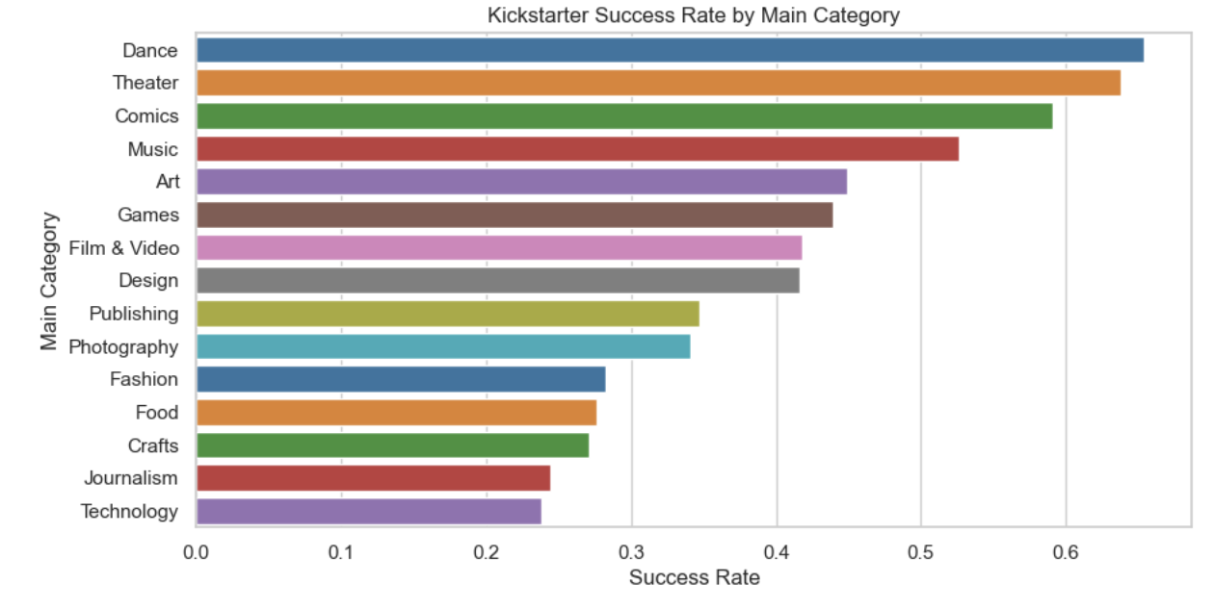
Figure 1. Bar Chart for Kickstarted Success Rate by Main Category
Figure 2 shows that success rates decline steadily as funding goals increase. Campaigns requesting under $1,000 succeed at around 55%, while those requesting over $100,000 succeed only about 8% of the time. The sharpest drop occurs above $50,000, where success rates fall below 17%. This directly answers research question 2. While there is no single optimal goal, campaigns with goals below $10,000 consistently outperform those with larger goals. This suggests that higher funding goals make campaigns seem less attainable to backers, reducing the likelihood of success. Creators should focus on setting the lowest realistic goal to maximize their chances of success.
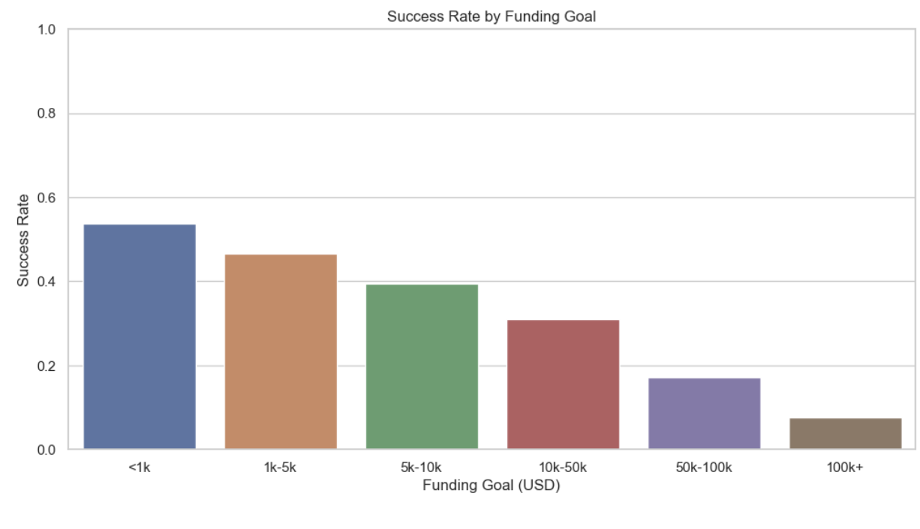
Figure 2. Bar Chart Showing Success Rate by Funding Goal
Figure 3 shows the ROC curves for all four models, comparing the true positive rate to the false positive rate across different decision thresholds. All curves lie above the diagonal baseline, which indicates that each model performs better than randomly guessing and has meaningful predictive power. In terms of performance, LDA and Decision Tree perform slightly better, both with an AUC of 0.686, followed by Logistic Regression at 0.682, and Random Forest is slightly lower at 0.666. All four models performed very similarly, with accuracy between 63–65% and AUC between 0.666 and 0.686. This tight clustering itself is important because it suggests that model performance is being limited more by the available features than by the choice of model.
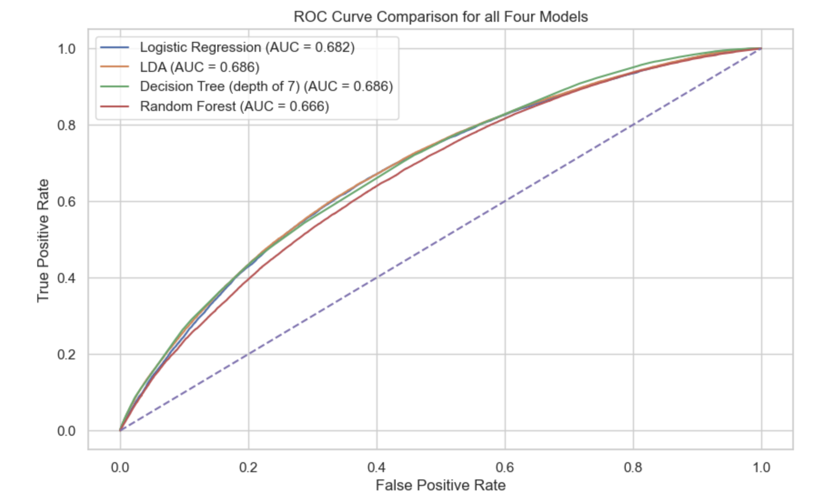
Figure 3. ROC Curve Comparison
Figure 4 shows the 15 most important features in the Logistic Regression model, separated into positive and negative effects with a reference line at zero. One key takeaway is that category variables are driving most of the prediction. On the positive side, Theater is the strongest predictor, with a coefficient of 0.67 and an odds ratio of 1.96. This means theater campaigns are nearly twice as likely to succeed compared to the baseline. Comics and Music also appear as strong positive predictors, reinforcing the trend we saw earlier that creative categories tend to perform better. On the negative side, categories like Fashion and Crafts have coefficients around -0.50, which lowers the odds of success by about 40%. This suggests that campaigns in these categories face more challenges in their funding goals. The log_goal variable is also important. Its negative coefficient and odds ratio of 0.76 confirm that higher funding goals reduce the likelihood of success, even after controlling for other factors like category and country. Country variables for the US and UK show a small positive effect, suggesting a slight home-market advantage, although the impact is relatively minor compared to other features. Since category variables dominate both the positive and negative sides of the chart, it’s clear that the model relies heavily on project type when predicting success. 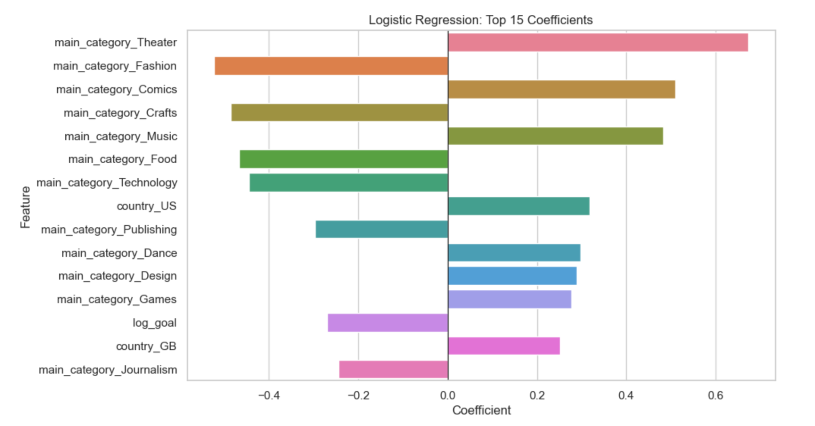Figure 4. Logistic Regression Top 15 Coefficients

However, the feature importance results in Figure 5 from the Random Forest model look drastically different from the Logistic Regression results. In this case, log_goal stands out as the most important feature by a wide margin, contributing much more predictive value than any other variable. After that, variables like campaign_days, launch_month, and launch_year follow, meaning that timing and campaign length also play a meaningful role. Overall, the four numerical features account for most of the model’s importance. In contrast, individual category variables like Music and Technology contribute relatively little on their own in the Random Forest model. This difference in results may seem like a discrepancy, but it actually reflects how the two models work differently and capture different aspects of data. While the Logistic Regression model isolates the independent role of each variable within the dataset, therefore emphasizing category variables, Random Forest evaluates the effectiveness of a feature's ability to split the data within decision trees, so numerical features have an advantage in that context because they provide more flexible split points than binary category variables.
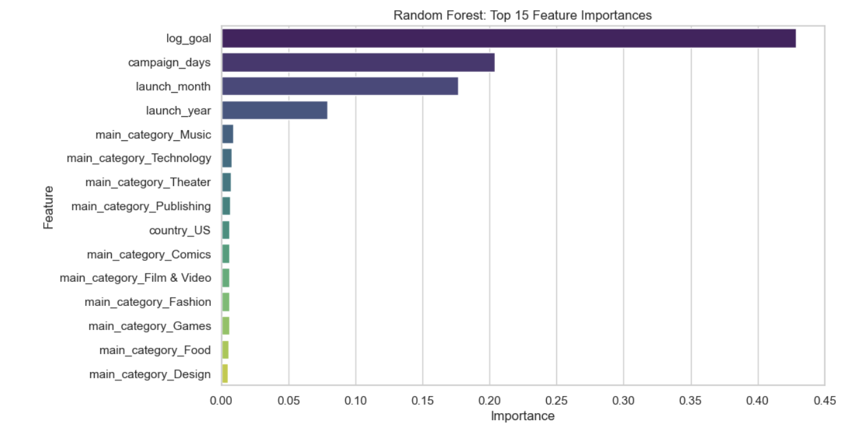
Figure 5. Random Forest Bar Chart by Feature Importance

Discussion

Our analysis aimed to answer three questions: what makes a Kickstarter campaign succeed or fail, is there an optimal funding goal, and what advice could we offer a creator launching a new campaign? Throughout the exploratory data analysis and model results, we came across a consistent pattern of what leads a campaign to success. Campaigns that were most likely to succeed had small and realistic funding goals, were in creative and performance categories, and ran for short periods of time rather than long, drawn-out campaigns. When these factors are combined, the success rate of the campaign increases compared to its peers. Several traits that reduce success include campaigns with large funding goals, product or technology-based categories, and longer campaign durations.

Addressing the second research question, there is no single optimal goal, but campaigns under $10,000 consistently outperformed larger ones. As funding goals increase, success rates decline, dropping to 17% as goals reach over $50,000. This pattern reinforces the idea that backers are more willing to support campaigns that feel achievable. While higher funding goals may reflect legitimate project needs, they introduce greater risk and require significantly stronger demand and visibility to succeed.

We would advise creators launching a campaign to focus first on setting a realistic and attainable funding goal. Creators should prioritize the minimum viable funding needed to execute their project rather than inflating targets. Success rates vary across different types of projects, so creators should study high-performing campaigns within the same category, which can provide valuable benchmarks and strategic insights. Campaign duration should also be planned carefully. Our findings suggest that shorter campaigns appear to create urgency and maintain momentum, whereas longer campaigns may lose visibility and engagement over time. Overall, the best strategy is to set a reasonable goal, understand category-specific trends, and choose an effective campaign length. Creators who optimize these three factors of goal size, category, and campaign duration will have the highest success rate based on our results.

While these findings provide meaningful insights, several limitations should be considered. Our analysis is based on historical Kickstarter data, which may not capture recent platform changes or external factors like marketing efforts, social media presence, or the creator's reputation. The models identify correlations between variables, but these factors may not directly cause success. Future research could include additional data, like backer engagement or early funding momentum, to understand how campaigns gain traction over time.

Overall, our results show that Kickstarter success isn’t random. It’s influenced by a few key decisions, including funding goal, category, and campaign length. Creators who consider these factors can give themselves a much better chance of reaching their funding goal.

References

Michalczyk, M. (2018). Kickstarter Projects. Kaggle. https://www.kaggle.com/datasets/kemical/kickstarter-projects

Author Contributions

Cooper Ritz: Completed final notebook including code, analysis, interpretations, and visualizations.

Tommy Devens: Partial Notebook completion, wrote sections 2, 3, and 4 on the report.

Grace Gavlinski: Reviewed the final notebook, wrote section 1, contributed to sections 2 and 5, and edited the report.

